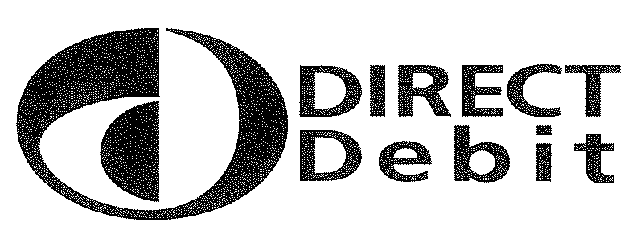
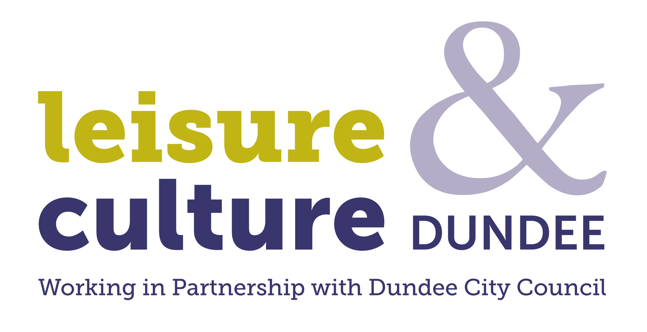 | Instruction to your  Bank or Building Society  to pay by Direct Debit
Please fill in the whole form using a ball point pen and send it to:

Leisure and Culture Dundee
1 Shore Terrace
Dundee
DD1 3AH

 |  |  |  | Service User Number
 |  |  |  | 5 | 5 | 7 | 1 | 4 | 3
 |  |  |  | Reference Number
Name(s) of Account Holder(s) |  |  |  | | | | | | | | | | | | | | | | | | |
_________________________________________________ |  |  |  | Instruction to your Bank or Building Society
 |  |  |  | Please pay Leisure and Culture Dundee Direct Debits from the account detailed in this Instruction subject to the Direct
Bank/Building Society Account Number |  |  |  | Debit Guarantee. I understand that this Instruction may remain with Leisure and Culture Dundee and, if so, details will
| | | | | | | |  |  |  | be passed electronically to my Bank/Building Society.
Branch Sort Code
| | | | |
Name and full postal address of your Bank or Building Society |  |  |  | Signature(s)  ______________________________________________________  ______________________________________________________  Date
To: The Manager
Address
Postcode

Banks and Building Societies may not accept Direct Debit Instructions for some types of account

------------------------------------------------------------------------------------------------------------------------------------------------------------------------------------
This Guarantee should be detached and retained by the Payer.

The Direct Debit Guarantee

• This Guarantee is offered by all banks and building societies that accept instructions to
pay Direct Debits

• If there are any changes to the amount, date or frequency of your Direct Debit Leisure and Culture Dundee will notify you fourteen working days in advance of your account being debited or as otherwise agreed. If you request Leisure and Culture Dundee to collect a payment, confirmation of the amount and date will be given to you at the time of the request

• If an error is made in the payment of your Direct Debit, by Leisure and Culture Dundee or your bank or building society, you are entitled to a full and immediate refund of the amount paid from your bank or building society
- If you receive a refund you are not entitled to, you must pay it back when Leisure and Culture Dundee asks you to.

• You can cancel a Direct Debit at any time by simply contacting your bank or building society. Written confirmation may be required. Please also notify us.

